Day 24 - 08th Aug 2025

Abstract Factory Design pattern

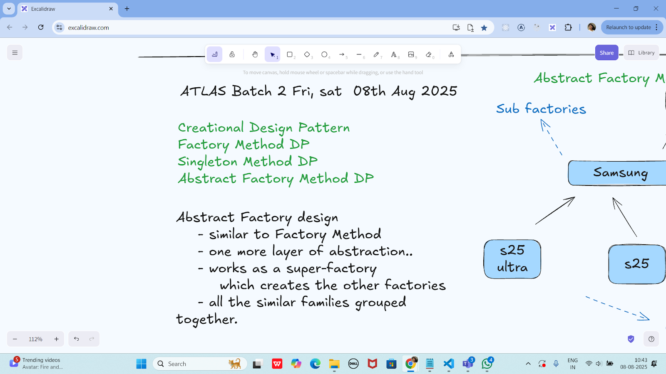

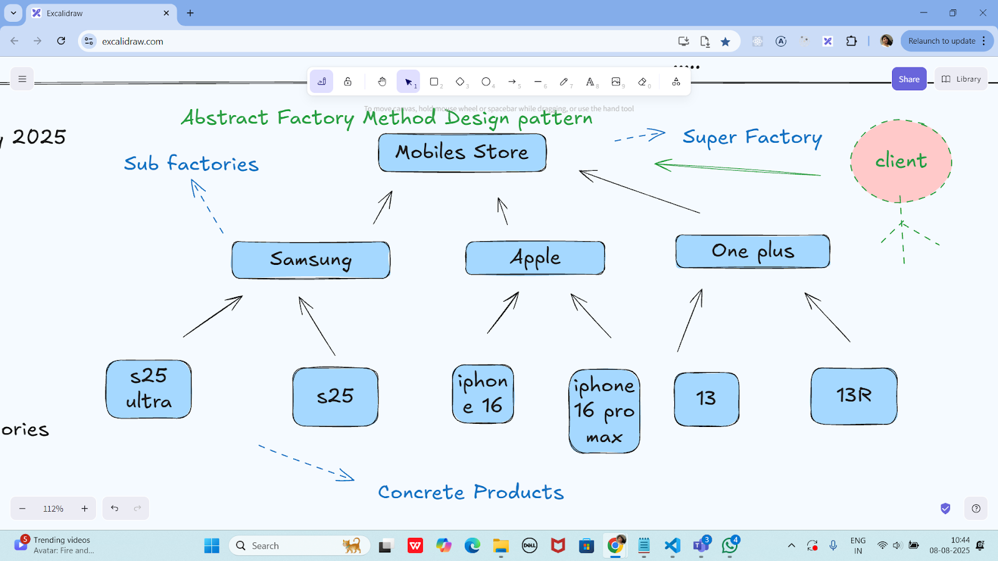

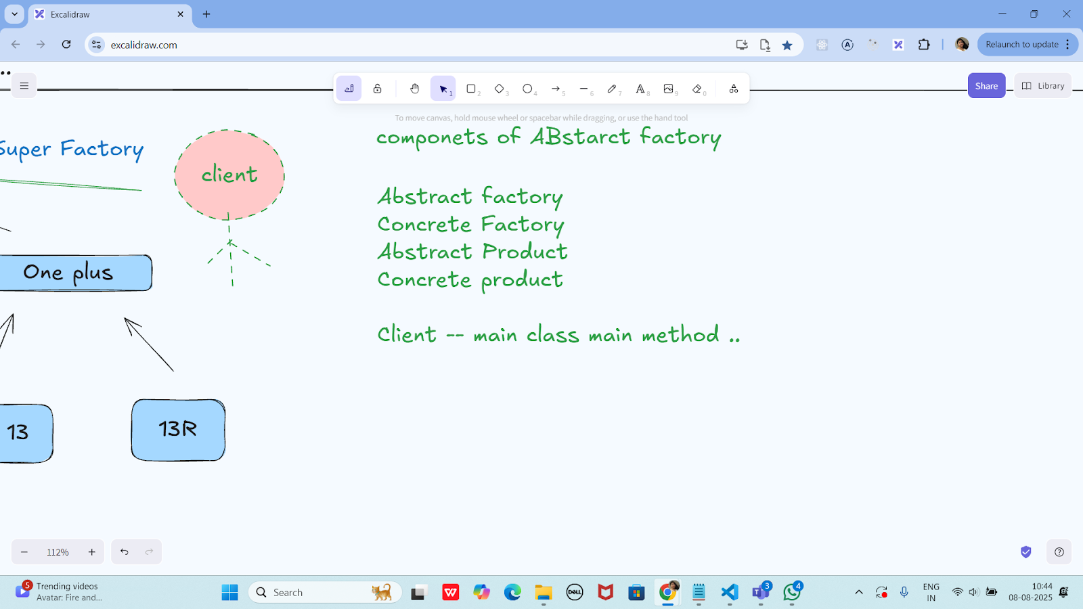

Task 01:
package Demo_Codes.Module_03_OOAD.AbstractFactoryDP.AbstractFactoryDpPack;

import java.util.Objects;

public class Apple {
private Apple() {
// Prevent instantiation
}

public static Mobile getMobile(String model) {
if (Objects.equals(model, "iphone16")) {
return new Mobile("Here is your iPhone 16");
} else if (Objects.equals(model, "iphone16MaxPro")) {
return new Mobile("Here is your iPhone 16 Max Pro");
}
return new NoMobile();
}
}
package Demo_Codes.Module_03_OOAD.AbstractFactoryDP.AbstractFactoryDpPack;

public class ClientAbstractFactory {
public static void main(String[] args) {
Mobile mObj = MobileStore.getMobile("Apple", "iphone16");
mObj.getDesc();
System.out.println("...");
}
}
package Demo_Codes.Module_03_OOAD.AbstractFactoryDP.AbstractFactoryDpPack;

public class Mobile {
String desc;

public Mobile(String model) {
this.desc = model;
}

public void getDesc() {
System.out.println(this.desc);
}
}
package Demo_Codes.Module_03_OOAD.AbstractFactoryDP.AbstractFactoryDpPack;

import java.util.Objects;

public class MobileStore {
private MobileStore() {
System.out.println("Hello, welcome to the world of Mobile");
}

public static Mobile getMobile(String brand, String model) {
if (Objects.equals(brand, "Apple")) {
System.out.println("Here are your Apple Models");
return Apple.getMobile(model);
}
// else if (Objects.equals(brand, "Samsung")) {
// System.out.println("Here are your Samsung Models");
// return Samsung.getMobile(model);
// }

return new NoMobile();
}
}
package Demo_Codes.Module_03_OOAD.AbstractFactoryDP.AbstractFactoryDpPack;

public class NoMobile extends Mobile {
public NoMobile() {
super("Sorry, invalid model");
}
}
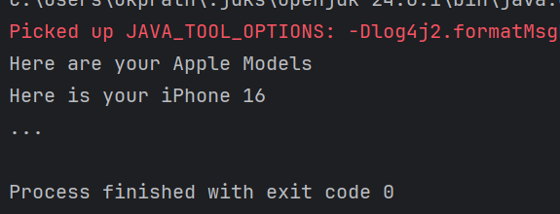

Hometask01

Adding samsung and oneplus in task 1

package hometask;

import java.util.Objects;

public class Apple {
private Apple() {
// Prevent instantiation
}

public static Mobile getMobile(String model) {
if (Objects.equals(model, "iphone16")) {
return new Mobile("Here is your iPhone 16");
} else if (Objects.equals(model, "iphone16MaxPro")) {
return new Mobile("Here is your iPhone 16 Max Pro");
}
return new NoMobile();
}
}
package hometask;

public class Mobile {
String desc;

public Mobile(String model) {
this.desc = model;
}

public void getDesc() {
System.out.println(this.desc);
}
}
package hometask;

import java.util.Objects;

public class MobileStore {
private MobileStore() {
System.out.println("Hello, welcome to the world of Mobile");
}

public static Mobile getMobile(String brand, String model) {
if (Objects.equals(brand, "Apple")) {
System.out.println("Here are your Apple Models");
return Apple.getMobile(model);
} else if (Objects.equals(brand, "Samsung")) {
System.out.println("Here are your Samsung Models");
return Samsung.getMobile(model);
} else if (Objects.equals(brand, "OnePlus")) {
System.out.println("Here are your OnePlus Models");
return OnePlus.getMobile(model);
}
return new NoMobile();
}
}
package hometask;

public class NoMobile extends Mobile {
public NoMobile() {
super("Sorry, invalid model");
}
}
package hometask;

import java.util.Objects; // ✅ add this

public class OnePlus {
private OnePlus() {
// Prevent instantiation
}

public static Mobile getMobile(String model) {
if (Objects.equals(model, "OnePlus12")) {
return new Mobile("Here is your OnePlus 12");
} else if (Objects.equals(model, "OnePlus12R")) {
return new Mobile("Here is your OnePlus 12R");
}
return new NoMobile();
}
}
package hometask;

import java.util.Objects;

public class Samsung {
private Samsung() {
// Prevent instantiation
}

public static Mobile getMobile(String model) {
if (Objects.equals(model, "S24")) {
return new Mobile("Here is your Samsung S24");
} else if (Objects.equals(model, "S24Ultra")) {
return new Mobile("Here is your Samsung S24 Ultra");
}
return new NoMobile();
}
}
package hometask;

public class ClientAbstractFactory {
public static void main(String[] args) {
Mobile m1 = MobileStore.getMobile("Apple", "iphone16");
m1.getDesc();

Mobile m2 = MobileStore.getMobile("Samsung", "S24");
m2.getDesc();

Mobile m3 = MobileStore.getMobile("OnePlus", "OnePlus12");
m3.getDesc();

Mobile m4 = MobileStore.getMobile("Apple", "iphone20"); // invalid
m4.getDesc();
}
}
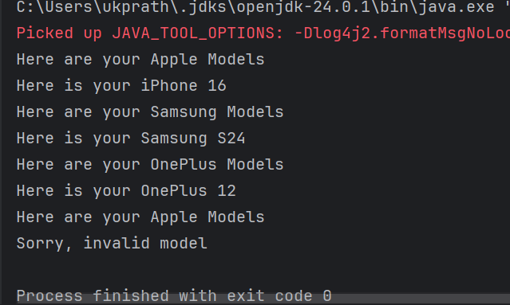

Builder method Design pattern

Task 02:
package Task02.BuilderDesignPattern;

class Laptop {
private int memory;
private int storage;
// Could add: graphicCard, processor, etc.

public Laptop() {
// Default constructor
}

// Getters and Setters
public int getMemory() {
return memory;
}

public void setMemory(int memory) {
this.memory = memory;
}

public int getStorage() {
return storage;
}

public void setStorage(int storage) {
this.storage = storage;
}

@Override
public String toString() {
return "Laptop{" +
"memory=" + memory +
"GB, storage=" + storage +
"GB}";
}
}
package Task02.BuilderDesignPattern;

interface LaptopBuilder {
LaptopBuilder buildMemory(int memory);
LaptopBuilder buildStorage(int storage);
Laptop build();
}
package Task02.BuilderDesignPattern;

class LaptopConcreteBuilder implements LaptopBuilder {
private Laptop laptop;

public LaptopConcreteBuilder() {
this.laptop = new Laptop();
}

@Override
public LaptopBuilder buildMemory(int memory) {
laptop.setMemory(memory);
return this;
}

@Override
public LaptopBuilder buildStorage(int storage) {
laptop.setStorage(storage);
return this;
}

@Override
public Laptop build() {
return laptop;
}
}

package Task02.BuilderDesignPattern;

class LaptopDirector {
private LaptopBuilder laptopBuilder;

public LaptopDirector(LaptopBuilder laptopBuilder) {
this.laptopBuilder = laptopBuilder;
}

public Laptop constructLaptop() {
return laptopBuilder
.buildMemory(16) // Example: 16GB RAM
.buildStorage(512) // Example: 512GB SSD
.build();
}
}
package Task02.BuilderDesignPattern;

public class ClientBuildMethodDP {
public static void main(String[] args) {
LaptopBuilder lbobj = new LaptopConcreteBuilder();
LaptopDirector dir = new LaptopDirector(lbobj);
Laptop lobj = dir.constructLaptop();

System.out.println(lobj);
}
}
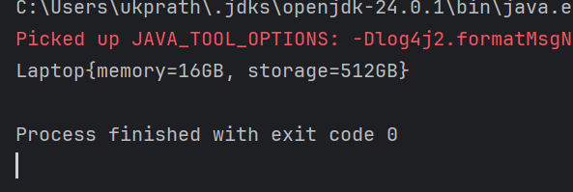

Task 03:
package Task03;

public interface Colors {
Colors clone();
String getName();
void setName(String name);
}
package Task03;

public class BlackConcretePrototype implements Colors {
private String name;

public BlackConcretePrototype() {
System.out.println("BlackConcretePrototype constructor is called");
}

public BlackConcretePrototype(String name) {
this.name = name;
}

@Override
public Colors clone() {
return new BlackConcretePrototype(this.name);
}

@Override
public String getName() {
return name;
}

@Override
public void setName(String name) {
this.name = name;
}
}
package Task03;

public class WhiteConcretePrototype implements Colors {
private String name;

public WhiteConcretePrototype() {
System.out.println("WhiteConcretePrototype constructor is called");
}

public WhiteConcretePrototype(String name) {
this.name = name;
}

@Override
public Colors clone() {
return new WhiteConcretePrototype(this.name);
}

@Override
public String getName() {
return name;
}

@Override
public void setName(String name) {
this.name = name;
}
}
package Task03;

public class Main {
public static void main(String[] args) {
Colors blackPrototypeObj = new BlackConcretePrototype("Black Color");
Colors whitePrototypeObj = new WhiteConcretePrototype("White Color");

Colors clonedBlackObj = blackPrototypeObj.clone();
Colors clonedWhiteObj = whitePrototypeObj.clone();

clonedBlackObj.setName("Dark Color");
clonedWhiteObj.setName("Light Color");

System.out.println("Black color is: " + clonedBlackObj.getName());
System.out.println("White color is: " + clonedWhiteObj.getName());
}
}
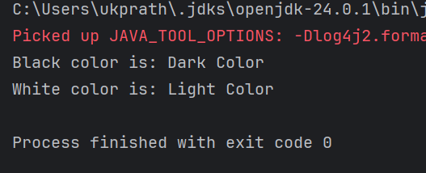
Prototype Method Design pattern
prototype interface -- Colors
Concrete prototype --- class
WhiteConcretePrototype
constructor()
constructor(String...)
clone()
BlackConcreteprototype
client code

Home tasks 01

Develop the below prototype method DP..

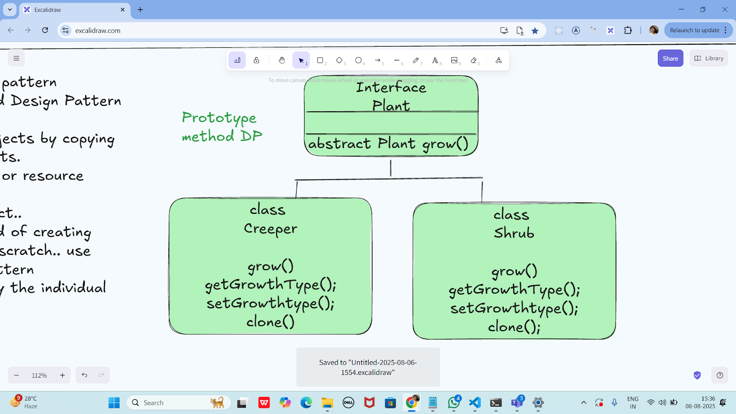

package prototype_Home_task;

public interface Plant extends Cloneable {
Plant grow();
String getGrowthType();
void setGrowthType(String growthType);
Plant clone();
}
package prototype_Home_task;

public class Creeper implements Plant {
private String growthType;

public Creeper() {
System.out.println("Creeper constructor is called");
}

public Creeper(String growthType) {
this.growthType = growthType;
}

@Override
public Plant grow() {
System.out.println("Creeper grows by spreading on the ground or climbing.");
return this;
}

@Override
public String getGrowthType() {
return growthType;
}

@Override
public void setGrowthType(String growthType) {
this.growthType = growthType;
}

@Override
public Plant clone() {
return new Creeper(this.growthType);
}
}
package prototype_Home_task;

public class Shrub implements Plant {
private String growthType;

public Shrub() {
System.out.println("Shrub constructor is called");
}

public Shrub(String growthType) {
this.growthType = growthType;
}

@Override
public Plant grow() {
System.out.println("Shrub grows as a small to medium-sized woody plant.");
return this;
}

@Override
public String getGrowthType() {
return growthType;
}

@Override
public void setGrowthType(String growthType) {
this.growthType = growthType;
}

@Override
public Plant clone() {
return new Shrub(this.growthType);
}
}
package prototype_Home_task;

public class Main {
public static void main(String[] args) {
// Original prototypes
Plant creeperPrototype = new Creeper("Climbing Plant");
Plant shrubPrototype = new Shrub("Bushy Plant");

// Cloning from prototypes
Plant clonedCreeper = creeperPrototype.clone();
Plant clonedShrub = shrubPrototype.clone();

// Changing clone names to prove independence
clonedCreeper.setGrowthType("Ground Spreader");
clonedShrub.setGrowthType("Flowering Shrub");

// Showing original and clone info
System.out.println("\nOriginal Creeper: " + creeperPrototype.getGrowthType());
System.out.println("Cloned Creeper: " + clonedCreeper.getGrowthType());

System.out.println("\nOriginal Shrub: " + shrubPrototype.getGrowthType());
System.out.println("Cloned Shrub: " + clonedShrub.getGrowthType());

// Growth actions
clonedCreeper.grow();
clonedShrub.grow();
}
}
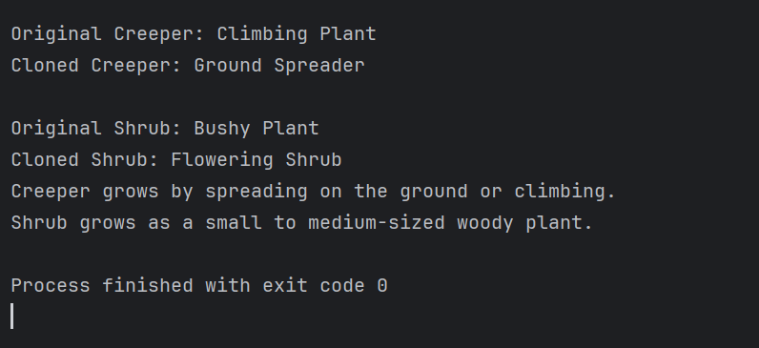

Task 04 Adaptor Design pattern

package Task04_Adapter_Design;

public class DellLaptop {
private ILaptopTarget powerSource;

public DellLaptop(ILaptopTarget powerSource) {
this.powerSource = powerSource;
}

public void charge() {
powerSource.charge();
}

public void removeCharge() {
powerSource.removeCharge();
}
}
package Task04_Adapter_Design;

public class ChargerAdaptee implements IChargerAdaptee {
public ChargerAdaptee() {}

@Override
public void charge() {
System.out.println("Charging my laptop");
}

@Override
public void removeCharge() {
System.out.println("Not charging my laptop");
}
}
package Task04_Adapter_Design;

public interface IChargerAdaptee {
void charge();
void removeCharge();
}
package Task04_Adapter_Design;

public interface ILaptopTarget {
void charge();
void removeCharge();
}
package Task04_Adapter_Design;

public class PowerSocketAdapter implements ILaptopTarget {
private IChargerAdaptee charger;

public PowerSocketAdapter(IChargerAdaptee charger) {
this.charger = charger;
}

@Override
public void charge() {
charger.charge();
}

@Override
public void removeCharge() {
charger.removeCharge();
}
}
package Task04_Adapter_Design;

public class Main {
public static void main(String[] args) {
System.out.println("Adapter Method Design Pattern");

IChargerAdaptee charger = new ChargerAdaptee();
ILaptopTarget adapter = new PowerSocketAdapter(charger);
DellLaptop dell = new DellLaptop(adapter);

dell.charge();
dell.removeCharge();
}
}
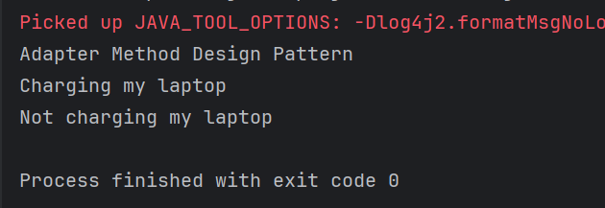

Info Box

Excalidraw updated at 10.43

https://excalidraw.com/#json=PfNv_D1GXzAH0yPsXLqss,ab_5Dl0GZWRrpJtLtyHOVg

Code for reference

https://drive.google.com/drive/folders/1LwhNov1s1-vHzF9GPAObLSnP9kAvipmw?usp=sharing

